**REACT**

**Day-12 23-12-2022 T SREE SOWMYA**

**CSE-04 IV YEAR**

**221910304044**

**Forward Ref hook and Controlled Component**

1. **Forward Ref Hook**

Code:

forwardRef.js

//import React,{Component} from 'react';

import React,{forwardRef} from 'react';

function User(props,ref)

{

return (

<div>

<input ref={ref} type="text"/>

</div>

)

}

export default forwardRef(User);

app.js

import './App.css';

import {useState} from 'react';

// import Gitamhyd from './Gitamhyd';

// import Student from './Student';

import User from './User'

// import React,{Component} from 'react';

// import GitamSowmya from './GitamSowmya';

import React,{useRef} from 'react';

function App()

{

let inputRef=useRef(null)

function updateInput()

{

inputRef.current.value="1000"

inputRef.current.style.color="Orange"

inputRef.current.focus()

}

return (

<div className="App">

<h1>forwardedRef in React</h1>

<User ref={inputRef}/>

<button onClick={updateInput}> Update Input Box</button>

</div>

);

}

export default App;

output

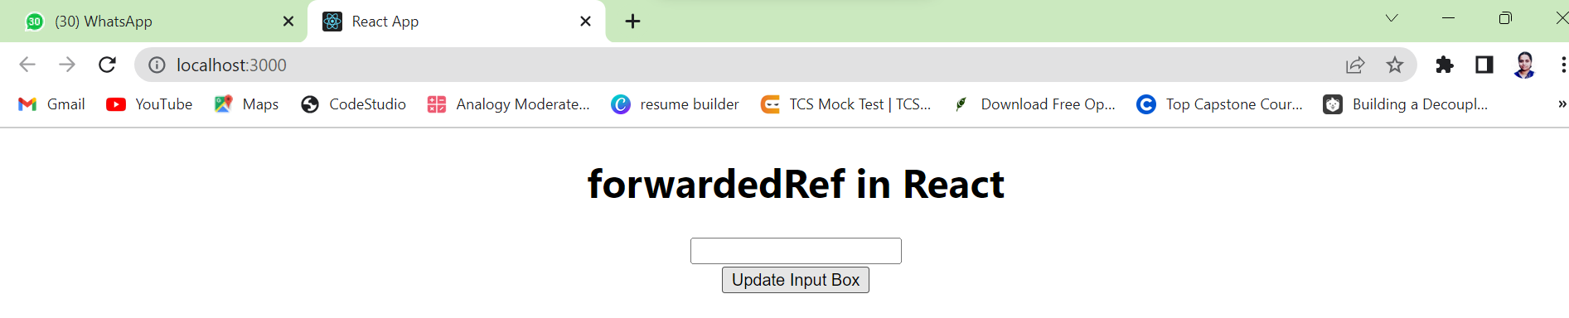

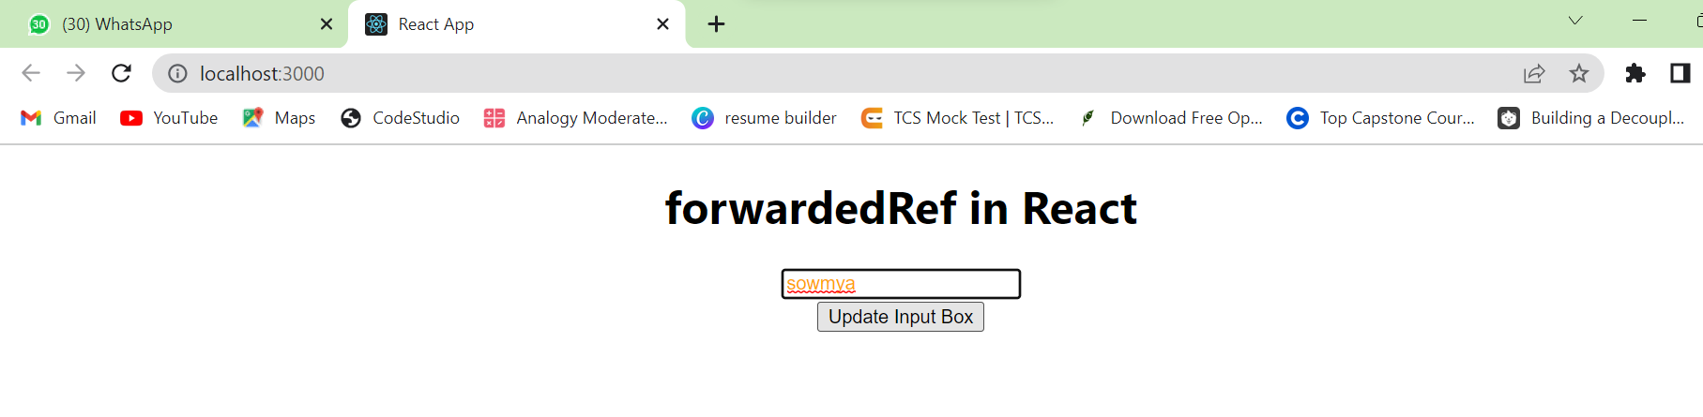

By default:

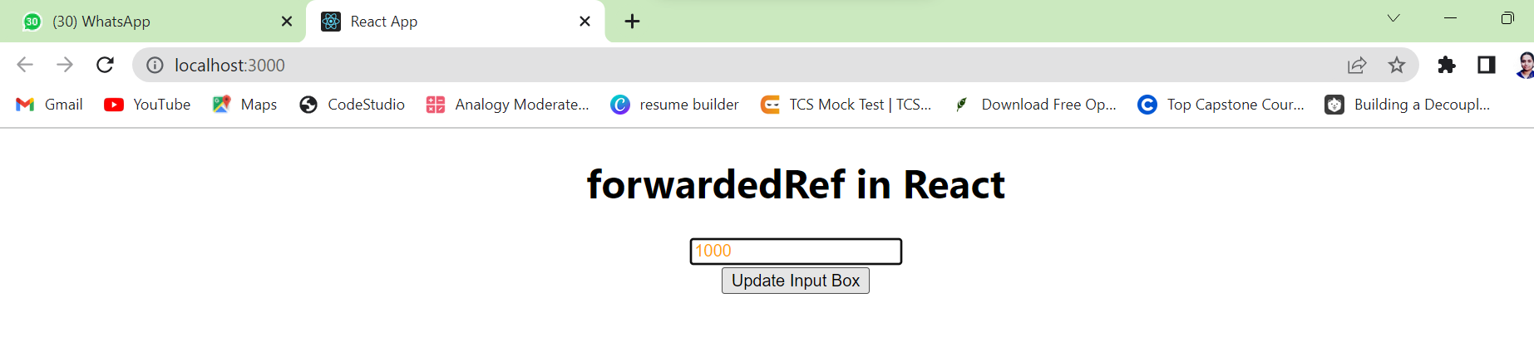

1. **Controlled Component:**

Code:

App.js

import React,{useState} from 'react';

function App()

{

const[val,setVal]=useState("")

return(

<div className="App">

<h1> Controlled Component</h1>

<input type="text" value={val} onChange={(e)=>setVal(e.target.value)}/>

<h1>{val}</h1>

</div>

);

}

export default App;

Output:

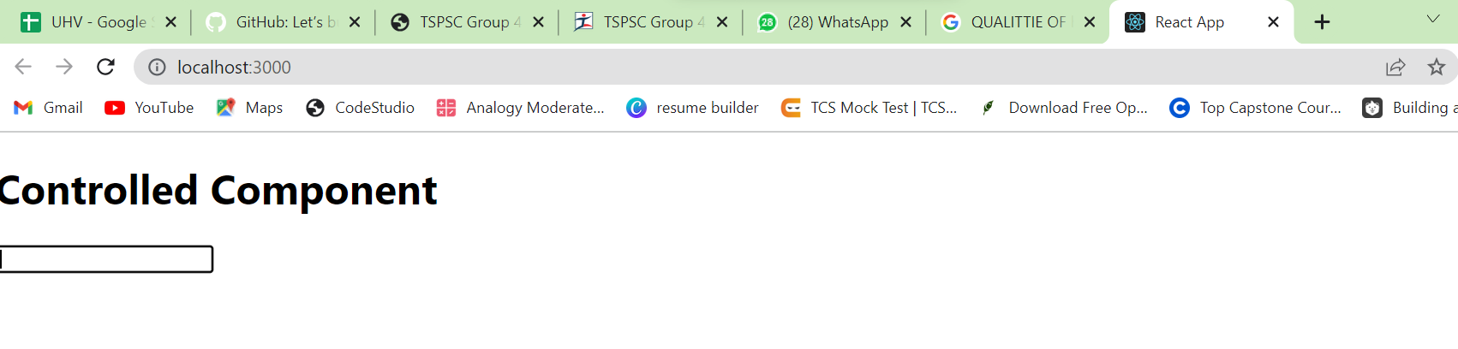

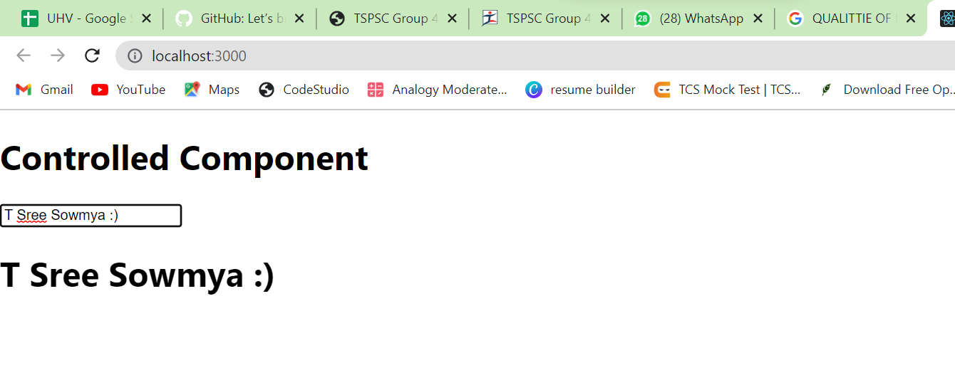

1. In app.js implement the function “update”.In that , the value of the state is “1000”. Return the value to the another component “student.js” by using forwardRef hook.

Student.js;

import React,{forwardRef} from 'react';

function Student(props,ref)

{

    return(

        <div>

            <input ref={ref} type="text" />

        </div>

    )

}

export default forwardRef(Student);

App.js:

import Student from './Student';

import React,{useRef} from 'react';

function App()

{

let inputRef=useRef(null)

function update()

{

inputRef.current.value="1000"

inputRef.current.style.color="None"

inputRef.current.focus()

}

return(

<div className="App">

<h1>forwardedRef in React</h1>

<Student ref={inputRef} />

<button onClick={update}> Update Input Box </button>

</div>

);

}

export default App;

Output:

initially

typing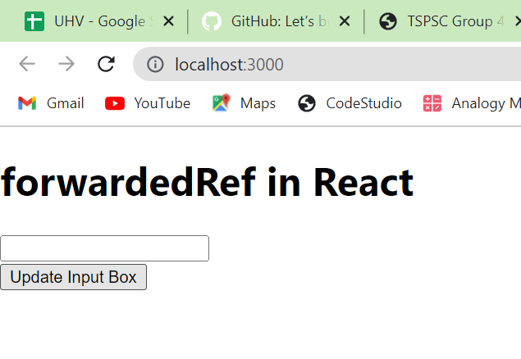

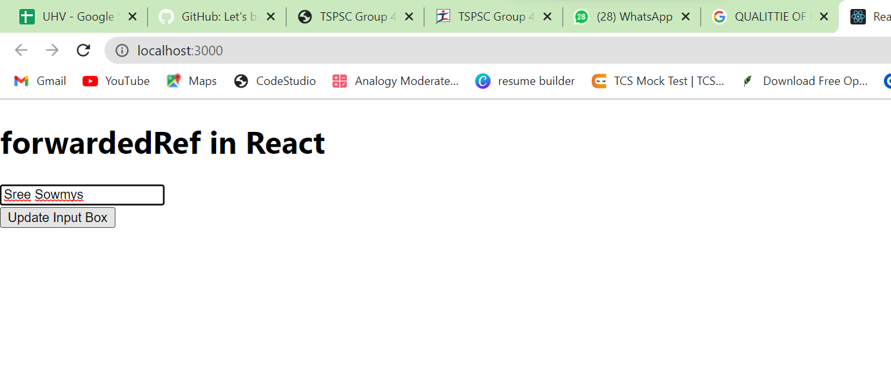

After updation

